|  |  |  |  |  |
| --- | --- | --- | --- | --- |
| **National University of Computer and Emerging Sciences, Lahore Campus** | | | | |
| C:\Users\saif\AppData\Local\Microsoft\Windows\Temporary Internet Files\Content.Word\final design.jpg | **Course:** | **Professional Issue in IT** | **Course Code:** | **CS449** |
| **Program:** | **BS(Computer Science)** | **Semester:** | **Fall-17** |
| **Duration:** | **1 Hr** | **Total Marks:** | **40** |
| **Paper Date:** | **14-04-2018** | **Weight** | **15 %** |
| **Section:** | **CS – A, B, C** | **Page(s):** | **5** |
| **Exam Type:** | **Midterm-2** |  |  |
| **Student: Name:______________________________ Roll No.________________ Section:_______** | | | | |
| **Instruction/Notes:** | No cheat sheets/books or helping material is allowed to be carried during the exam.  Attempt all questions. Please write concisely and use the allocated space for each question. | | | |

Question 1: Choose the best answer (10 marks)

1. The organization is structured by:

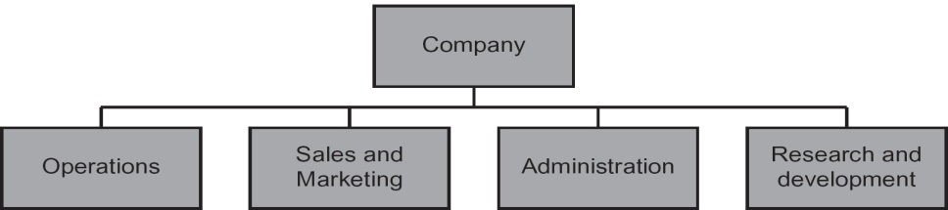

* 1. **Function**
  2. Product-line
  3. Technology
  4. Market Sector

1. In an organization, professionals prefer _________ structure:
   1. Deep
   2. **Flatter**
   3. Both
   4. None of the above
2. Choosing a friend or a former colleague is an example of :
   1. **Cronyism**
   2. Nepotism
   3. Fraud
   4. Misrepresentation
3. Working part-time at a company that sells a competing product or service as your full-time employer. What is this ethical issue called:
   1. **Conflict of interest**
   2. Fraud
   3. Misrepresentation
   4. Breach of contract
4. Employer no longer requires people to do a particular category of job is:
   1. Constructive dismissal
   2. **Redundancy**
   3. Termination
   4. None of the above
5. The Facebook–Cambridge Analytica data scandal involves the collection of [personally identifiable information](https://en.wikipedia.org/wiki/Personally_identifiable_information) of up to 87 million [Facebook](https://en.wikipedia.org/wiki/Facebook) users that [Cambridge Analytica](https://en.wikipedia.org/wiki/Cambridge_Analytica) began collecting in 2014. The data was used to influence voter opinion on behalf of politicians who hire them. Following the breach, Facebook apologized and experienced public outcry and lowered stock prices, calling the way that Cambridge Analytica collected the data "inappropriate." This process is called:
   1. Workplace monitoring
   2. **Consumer profiling**
   3. E-discovery
   4. Identity theft
6. ______ is the crime of obtaining goods, services, or property through deception or trickery.
   1. Conflict of interest
   2. **Fraud**
   3. Misrepresentation
   4. Perjury
7. _______involves providing money, property, or favours to someone in business

or government to obtain a business advantage.

* 1. Fraud
  2. **Bribery**
  3. Gift
  4. Perjury

1. A written statement that is false and that harms another person is called:

a. a lie

b. slander

c. **libel**

d. freedom of expression

1. A lawsuit in which the true identity of the defendant is temporarily unknown is called a

_________________ lawsuit.

* 1. Subpoena
  2. Remailer
  3. **John Doe**
  4. Anonymous

Question 2: You pay a $6000 installment for car each year, for 2 years starting from next year. What is the net present value of this investment considering an interest rate of 10%? Show the working to calculate the values. (5 marks)

|  |  |  |
| --- | --- | --- |
| Year | Value | Present Value |
| 1 | 2,000 |  |
| 2 | 2,000 |  |

Question 3: Define the term “Resume Inflation” and explain how it is against the professional ethics?

(5 marks)

Question 4: What is ***Strict Liability*** in ***Software*** ***Product Liability***.? Three defenses ***Doctrine of supervening event***, ***Government contractor defense*** and ***Expired statute of limitation*** a defendant can take against ***Strict Liability***. Explain each briefly. (5 marks)

Question 5: Anonymity on the internet is important for internet users, while a few people also oppose this freedom given in the name of freedom of expression. State arguments given on both sides. (5 marks)

Question 6: State arguments put in favor and against of bureaucratic model in organization. (5 marks)

Question 7: What benefits can consumer profiling provide to you as a consumer? Do these benefits outweigh the loss of your privacy? (5 marks)